

***Misr University of Science and Technology***

***College of Engineering and Technology***

***Department of Mechatronics Engineering***

B. Eng. Final Year Project

**3 Proposals for Graduation Projects**

By:

*GROUP ( 7 )*

|  |  |
| --- | --- |
| *NAME* | *ID* |
| Abanob Malak | 95689 |
| Kareem Ahmed | 95635 |
| Omar Mohamed | 95668 |
| Magdy Maged | 91672 |
| Essam Alaa | 91679 |

Supervised By:

*Supervisor(s)*

|  |  |
| --- | --- |
| *Dr. Bahaa Nasser* | *Head of Department* |
| *Prof. Dr. Mohamed Hamdy* | *Department professor* |
| *Prof. Dr. Mohamed Ibrahim* | *Menofia University Professor* |
| *Dr. Alaa Zakria Nasser* |  |
| *Dr. Ahmed Sabri* |  |
| *Dr. Bekhet Mohamed* | *Japanese University* |
| *Ass. Prof. Tahani Wileam* | *Beni-suef University* |
|  |  |

*Date of final report*

*9/10/2024*

DECLARATION

I hereby certify that this material, which I now submit for assessment on the programme of study leading to the award of Bachelor of Science in Mechatronics Engineering is entirely my/our own work, that I/we have exercised reasonable care to ensure that the work is original, and does not to the best of my knowledge breach any law of copyright, and has not been taken from the work of others and to the extent that such work, if any, has been cited and acknowledged within the text of my work.

**Signed:** _____________________________

**Date:**

**Signed (repeat for all students):** _____________________________

_____________________________

_____________________________

_____________________________

_____________________________

**Date:**

**Project1:**

**Advanced Driving Assistance Systems(ADAS)**

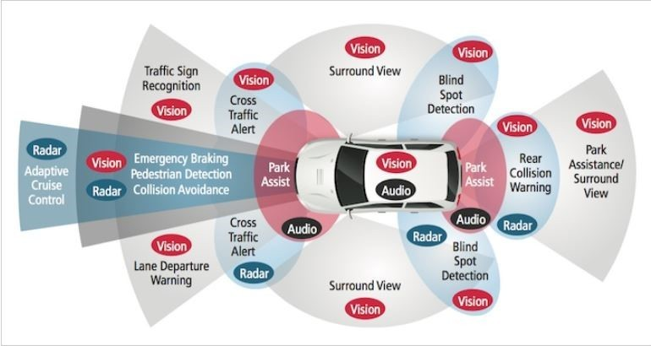

# ABSTRACT For:

**Advanced Driver Assistance Systems (ADAS)**

Advanced Driver Assistance Systems (ADAS) represent a pivotal advancement in automotive technology, aiming to enhance vehicle safety and the overall driving experience. This abstract explores the key components, functionalities, and benefits of ADAS. ADAS integrates a multitude of sensors, cameras, and radar to contribute to the overall goal of reducing accidents, minimizing human errors, and improving road safety. The benefits of ADAS extend beyond safety improvements. By providing drivers with real-time information and assistance, ADAS aims to reduce the cognitive load on drivers, enhancing overall comfort and reducing driver fatigue. Additionally, as these systems continue to evolve, they play a crucial role in laying the foundation for autonomous driving technologies.

Our project specifically handles the following systems:

1. **Road Sign Recognition**
2. **Interactive Surface**
3. **Blind Spot Detection**
4. **Adaptive Cruise Control**
5. **utilizes steering by Ackerman chassis** to enhance maneuverability.
6. **Road Sign Recognition**, a core ADAS feature, uses advanced image processing and machine learning (ML). Cameras capture road signs like speed limits, stop signs, and directional markers, while ML models analyze the data. This real-time recognition system alerts drivers by displaying key information on an interactive surface, keeping them aware of current road conditions and regulations for safer driving.
7. The **Interactive Surface** with a graphical user interface (GUI) is the primary user interaction point in ADAS. It projects important information, such as obstacle detection and navigation alerts, onto the windshield. The touch-sensitive interface allows drivers to customize settings, respond to alerts, and control ADAS functionalities with ease.
8. **Blind Spot Detection** systems help reduce accidents caused by lane change maneuvers by monitoring areas outside the driver’s view. The system provides real-time feedback, alerting drivers to vehicles in their blind spots, thus enhancing safety during lane changes.
9. **Adaptive Cruise Control** is designed to maintain a safe and constant distance between the host vehicle and the vehicle in front while also adapting the vehicle's speed to suit traffic conditions. These systems use a range of sensors, such as radar or LiDAR, to continuously monitor the distance and relative speed of vehicles ahead

Contents

ABSTRACT For: 4

List of Figures 8

List of Acronyms/Abbreviations 9

1 Chapter 1 Introduction and Literature review 1

1.1 Introduction 1

1.2 Problem Statement 2

1.3 Project Description 3

1.4 Literature Review 3

1.5 Conclusion 4

2 Chapter 2: Project Design 5

2.1 Project Purpose and Constraints 5

2.2 Project Specifications 6

2.2.1 Chassis Design 6

2.2.2 Road Sign Recognition (RSR): 11

2.2.3 Blind Spot Detection: 13

2.2.4 Adaptive Cruise Control (ACC): 14

Scientific Methodologies and Theories for ACC 15

2.3 Core components: 16

2.4 Design Alternatives and Justification 17

2.5 Description of the Selected Design 17

2.6 Block Diagram and Subsystem Functions 18

2.7 Expected cost 19

2.8 Environmental Impact 19

2.9 Manufacturability 19

2.10 Ethics 20

2.11 Social and Economic Impact 20

2.12 Health and Safety 20

2.13 Sustainability 21

References 22

ABSTRACT For Autonomous vehicles 2

1. Introduction and Literature review 3

2. Mechanical design Project Design 3

Introduction: 3

Material: 3

3. Difference between Self-Driving Cars and Regular Cars: 4

2.14 Advantages of Self-Driving Cars: 4

4. Autonomous vehicle Levels of Autonomous 5

2.15 Autonomous Vehicle Technologies: 6

2.16 Working of Automated Vehicle: 6

2.17 Development of Autonomous Vehicles: 7

1 ABSTRACT 10

2 Chapter one: Introduction and Literature review 11

2.1 Introduction 11

2.2 Literature Review 12

3 Chapter 2: Project Design 14

3.1 Components and Circuit Design 14

3.1.1 Smart Lighting System 14

3.1.2 Environmental Alert System 14

3.1.3 Water Level Monitoring System 15

3.1.4 Smart Door System (RFID/NFC) 15

3.1.5 Smart Curtain System 15

4 Conclusion 16

# List of Figures

Figure 1 ADAS LEVELS 1

Figure 2 reasons for pre-crash event 2

Figure 3 "Prototype of Small-Scale Vehicle Model Demonstrating ADAS Features" 5

Figure 4 "Ackerman Chassis" 6

Figure 5 "steering with servo motors" 7

Figure 6 "mesh analysis example 9

Figure 7 Illustration of toe, camber, and caster angles for vehicle wheel alignment. 10

Figure 8 "EXAMPLE OF ROAD SIGN RECOGNITION" 11

Figure 9 "Car blind spots and rearview mirror coverage." 13

Figure 10 "TF-Luna sensor: detection distance and corresponding object size." 16

# List of Acronyms/Abbreviations

ACC Adaptive Cruise Control

ADAS Advanced Driver Assistance Systems

AI Artificial intelligence

BSD Blind Spot Detection

CNNS Convolutional neural networks

LiDAR Light Detection and Ranging

ML Machine learning

TSR Traffic Sign Recognition

YOLO You only look once

# Chapter 1 Introduction and Literature review

## Introduction

The automotive industry has witnessed significant advancements in recent decades, with one of the most impactful being the development of Advanced Driver Assistance Systems (ADAS). These systems aim to enhance vehicle safety, improve the overall driving experience, and reduce accidents caused by human error. By integrating cutting-edge technologies like sensors, cameras, and machine learning algorithms, ADAS assists drivers with real-time feedback, warning systems, and even semi-autonomous vehicle control as in Figure (1). The increasing demand for safer and smarter vehicles has spurred the continuous evolution of ADAS, laying the foundation for future fully autonomous driving systems.



Figure 1 ADAS LEVELS

This project focuses on developing an ADAS model specifically designed for a small-scale vehicle kit. The project’s objective is to implement core ADAS functionalities, including **Road Sign Recognition**, **Blind Spot Detection**, **Adaptive Cruise Control**, and an **Interactive Surface** for driver feedback. Additionally, the vehicle employs **steering via an Ackerman chassis**, which improves its maneuverability and simulates realistic turning mechanics, essential for providing accurate obstacle avoidance. The integration of these systems will not only enhance safety but also contribute to the ongoing development of intelligent transportation technologies.

## Problem Statement

As road traffic continues to increase globally, the risks of accidents and driver errors become more pronounced as shown in Figure (2). While modern vehicles are equipped with some form of ADAS, many current solutions still rely heavily on driver input. The challenge is to create a more comprehensive, reliable, and adaptable ADAS solution that can mitigate potential accidents by reducing human error and improving overall driving performance. This project addresses these challenges by integrating advanced features into a small vehicle prototype, ensuring real-time safety monitoring, traffic sign recognition, and adaptive driving responses. Furthermore, the use of an Ackerman chassis steering system provides a more realistic model for testing steering dynamics in ADAS-equipped vehicles.



Figure 2 reasons for pre-crash event

## Project Description

The project aims to develop a scaled-down model of an ADAS-equipped vehicle that demonstrates essential functionalities. The system will include **Road Sign Recognition**, where machine learning algorithms will detect and process traffic signs in real-time, and **Blind Spot Detection**, which will alert drivers of nearby vehicles outside their field of vision. **Adaptive Cruise Control** will enable the vehicle to maintain a safe distance from the car ahead, adapting speed as necessary, and an **Interactive Surface** will provide a user-friendly interface for displaying system feedback and alerts. The **Ackerman chassis steering system** enhances the vehicle's ability to navigate curves and perform precise turns, which is crucial for obstacle detection.

## Literature Review

The development of ADAS has seen tremendous progress over the years. Research in sensor technologies, machine learning, and computer vision has paved the way for more advanced driving systems. Early ADAS systems, such as basic cruise control and parking sensors, have evolved into more sophisticated systems capable of lane-keeping, automatic emergency braking, and even partial autonomous driving. These developments have been driven by an increasing focus on road safety, regulatory standards, and consumer demand for smarter vehicles.

Several studies highlight the importance of **Road Sign Recognition** in improving road safety. Using machine learning algorithms and computer vision techniques, modern ADAS systems can accurately detect and classify road signs, providing drivers with timely alerts and reducing the risk of violations. Research by **Ciresan et al. (2012)** demonstrated the effectiveness of convolutional neural networks (CNNs) in road sign detection, with real-time processing being a critical factor in ensuring the system’s accuracy.

Similarly, **Blind Spot Detection** has become a key feature in ADAS due to the high number of lane-change-related accidents. By using sensors such as radar and LiDAR, blind spot detection systems monitor areas that are often outside the driver's view. Studies like Park et al. (2016) have shown that blind spot detection can reduce collisions by up to 14%, significantly improving driver safety.

**Adaptive Cruise Control** (ACC) is another critical component, providing the ability to maintain a consistent following distance from the vehicle ahead. Research in this field has explored the use of radar and LiDAR technologies to improve ACC’s response times and accuracy. A study by Milanés and Shladover (2014) highlights the increasing reliability of ACC systems in dynamically adjusting to changing traffic conditions, thereby reducing driver fatigue during long journeys.

The use of an **Interactive Surface** to display real-time feedback has also gained traction in recent years. By integrating user-friendly graphical interfaces, drivers can receive clear and immediate information regarding the vehicle’s status, warnings, and ADAS functions. Research by Young and Stanton (2007) demonstrated that an intuitive interface significantly improves the driver’s situational awareness, leading to safer driving behavior.

In the domain of **vehicle steering and maneuverability**, the Ackerman steering geometry is commonly used in both small and full-sized vehicles to optimize turning angles and ensure proper wheel alignment. The use of the Ackerman chassis in this project mimics realistic vehicle dynamics, improving the accuracy of the ADAS system in situations requiring lane tracking and obstacle avoidance.

## Conclusion

The rest of this report is organized as follows. Chapter 2 provides a detailed analysis of the design and implementation of the ADAS systems within the project, including the hardware and software components used.

# Chapter 2: Project Design

## Project Purpose and Constraints

The purpose of this project is to develop a small-scale Advanced Driver Assistance System (ADAS) model that demonstrates critical functionalities in improving vehicle safety and enhancing the driving experience. This scaled-down system, implemented on a vehicle like that in Figure(3), will include features such as **Road Sign Recognition, Blind Spot Detection, Adaptive Cruise Control, and an Interactive Surface** for real-time feedback. The main objective is to simulate real-world ADAS applications on a smaller platform, providing a foundation for more advanced autonomous driving technologies.

The project faces several constraints, including limited space for components due to the vehicle’s small size, budget limitations, and the requirement to integrate a wide range of sensors and technologies without exceeding power and processing capacity. Another constraint is ensuring real-time system responses, which requires efficient software integration between hardware A machine with wheels on a grey floor
1components like the Jetson Nano board, LiDAR, cameras, and sensors.

Figure 3 "Prototype of Small-Scale Vehicle Model Demonstrating ADAS Features"

## Project Specifications

### Chassis Design

#### Ackermann Chassis

The ADAS prototype utilizes an Ackermann chassis structure, enabling efficient vehicle control with rear-wheel drive and front-wheel steering. This setup mimics the mechanism of real vehicles, offering essential functions such as forward and reverse movement, along with wide radius steering for navigation. Although this design does not support in-place steering, the Ackermann configuration provides excellent manoeuvrability and a certain level of climbing capability, making it suitable for ADAS applications where stable turning is critical.

The core principle of Ackermann steering lies in ensuring that the front wheels rotate around a common origin during turns, allowing each wheel to follow a natural arc. This setup significantly reduces the chance of wheel slippage or uneven wear during steering.

Figure 4 "Ackerman Chassis"

#### Ackermann Steering Working Principle

The Ackermann steering geometry was initially developed to improve the turning capability of carriages and has since become a key component in automotive design. It ensures that the inside and outside wheels turn at different angles, with the inner wheel turning at a sharper angle to ensure both wheels follow arcs of the same radius. This behavior improves vehicle stability and prevents the skidding effect caused by inconsistent turning paths.

The steering mechanism consists of:

* **Servo Motors and Links**: These control the movement of the front wheels, determining the turning angle and direction like that in the figure.
* **Rear-Wheel Motor Drive**: The rear wheels are driven by a motor, which provides the power required for forward and backward movement.

Figure 5 "steering with servo motors"

During turning, if the front wheels are in a parallel state, their paths do not converge, leading to a dragging sensation. Instead, the rotation angle of the inner wheel must be larger than that of the outer wheel. This ensures that both front wheels follow a trajectory that converges at a common center, providing a smoother turning experience. The relationship between the angles of the inner and outer wheels can be expressed using Ackermann geometry:

The calculated values ensure that the vehicle remains stable during turns, with each wheel rotating around a common center, preventing skidding and improving overall safety.

#### Mechanical Analysis of the Body

To ensure the stability and structural integrity of the prototype, a comprehensive analysis of the body structure was conducted. This analysis involved calculating the weight distribution and conducting mesh analysis on the chassis and body components.

* **Weight Analysis**:
  + A detailed weight analysis was performed to determine the weight distribution across the vehicle. This analysis is crucial to ensure that the center of gravity remains low and centered, which enhances stability during turns and helps prevent rollovers. The weight of various components, such as the battery pack, sensors, and actuators, was considered in the calculation.
* **Mesh Analysis**:
  + 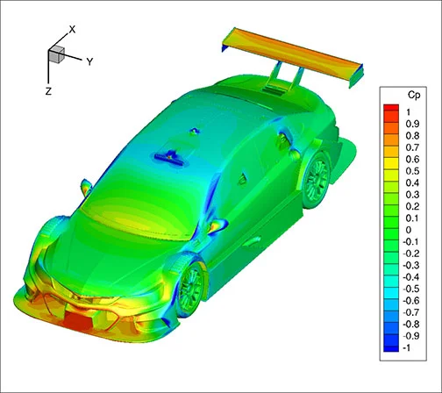Mesh analysis was conducted on the chassis and body components using finite element analysis (FEA) software to assess the stress and strain under different load conditions. This type of analysis helps identify potential points of failure and ensures that the structure can withstand the forces encountered during operation. The mesh analysis results guided the selection of materials and the design of structural reinforcements to improve durability while minimizing weight.

Figure 6 "mesh analysis example

#### Vehicle Steering and Wheel Angles Calculation Formulas

The following calculations were used to ensure accurate steering geometry and maintain vehicle stability:

* **Toe Angle**: The toe angle is calculated to maintain proper wheel alignment, improving steering response and reducing tire wear.

* **Caster Angle:** The caster angle ensures the steering axis is tilted, providing a self-cantering effect that enhances directional stability.

* **Camber Angle:** The camber angle impacts tire contact with the road and stability during turns.

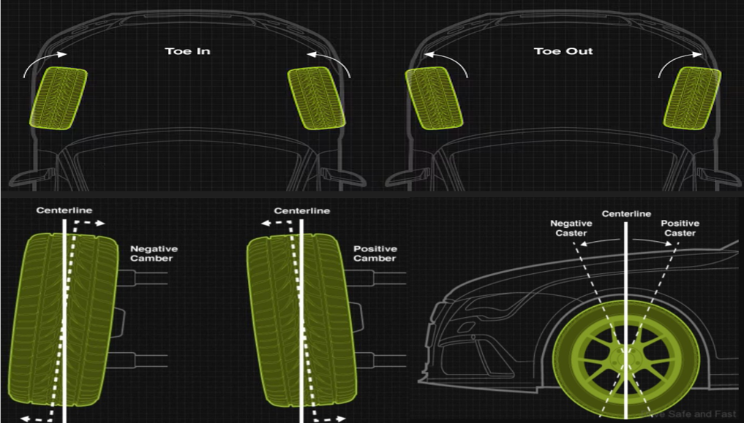

Figure 7 Illustration of toe, camber, and caster angles for vehicle wheel alignment.

### Road Sign Recognition (RSR):

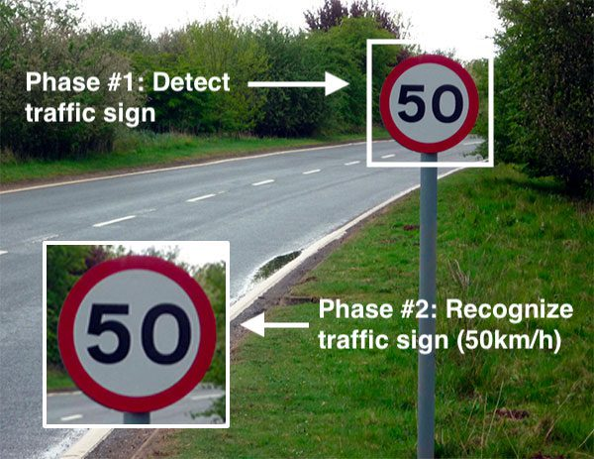

Figure 8 "EXAMPLE OF ROAD SIGN RECOGNITION"

##### **How does Road Sign Recognition work**?

Detect and classify road signs using a camera and machine learning algorithms.

##### **Scientific Methodologies and Theories for Road Sign Recognition:**

Our methodology includes selecting and acquiring relevant datasets (such as the Egypt and German datasets), splitting the data into training and validation sets, training the AI model using this data, and evaluating its performance with real-world scenarios.

**Importance of AI and Model Selection:**

Selecting the right AI model is crucial for traffic sign recognition, as it must meet specific performance criteria. Different models offer varying strengths, including real-time processing capabilities, accuracy, adaptability to different conditions, and efficiency on devices with limited resources.

AI models play a key role in interpreting visual data from road signs by utilizing advanced deep learning architectures. These models enable vehicles to analyze images or video frames effectively, allowing them to respond appropriately to dynamic road conditions.

The choice of AI model depends on several factors:

* Real-Time Processing: Ensures timely detection and classification of traffic signs.
* Accuracy: Guarantees precise recognition to enhance safety and compliance.
* Efficiency: Optimizes performance on devices with constrained computational resources.
* Adaptability: Handles diverse environmental conditions, such as varying lighting and weather

**Balancing Real-time Performance and Accuracy:**

Achieving a balance between real-time performance and accuracy is crucial for applications such as autonomous vehicles. Models must process data swiftly while maintaining high accuracy to ensure safe and reliable operation in intelligent transportation systems.

##### **Key AI Models:**

Several AI models have proven effective in Road Sign Recognition. Real-time object detection models, such as YOLO and SSD, have significantly advanced the capabilities of TSR systems, providing a solid foundation for developing reliable, high-performance solutions.

### Blind Spot Detection:

##### **Working principle:**

**Monitor surrounding areas using radar or LIDAR to warn of nearby vehicles

Figure 9 "Car blind spots and rearview mirror coverage."

1. ***Sensor Monitoring*:**  
   The BSD system continuously monitors the vehicle’s blind spot areas using strategically placed sensors. These sensors provide real-time information about objects or vehicles present in these zones.
2. ***Object Detection*:**  
   The sensors detect objects within the blind spot areas by emitting signals (radio waves, sound waves, or capturing visual data) and analyzing the returning signals or images. The data processing unit analyzes this information to identify and classify objects.
3. ***Object Position Determination*:**  
   The system determines the position, speed, and trajectory of detected objects relative to the vehicle’s position and movement. This helps assess the risk of a potential collision.
4. ***Alert Generation***:  
   If an object in the blind spot poses a potential risk, the system triggers alerts to notify the driver. These alerts can be:
   * Visual Alerts: Displayed on the side mirrors, dashboard, or heads-up display, using icons or symbols to indicate the presence of an object or vehicle.
   * Auditory Alerts: Beeps or spoken messages to draw the driver’s attention to the presence of an object or vehicle in the blind spot.
5. ***Driver Response*:**  
   Upon receiving an alert, the driver can take appropriate action, such as delaying a lane change, adjusting speed, or checking the blind spot and mirrors more carefully before proceeding. These alerts improve driver awareness and decision-making, reducing the likelihood of blind spot-related accidents.

### Adaptive Cruise Control (ACC):

Maintain a safe distance from other vehicles using sensors to monitor speed and distance. ACC employs a **depth camera** and **LiDAR** to monitor the distance between the car and preceding vehicles. By autonomously adjusting the car's speed and following distance, ACC ensures a safe and consistent driving experience, particularly in congested traffic conditions.

Scientific Methodologies and Theories for ACC:

* **Adaptive Cruise Control System**: AI Model and Algorithm Research, Component Acquisition, System Architecture Design, setting up Jetson Nano and Camera, AI Model Development.
* **Working of Adaptive Cruise Control:**
  + the radar or LiDAR sensor transmits signals at a given frequency toward an incoming car.
  + The reflected signals return at a different frequency, depending on the relative speed of the car being tracked.
  + A processing device compares the transmitted frequency to the received frequency to determine the speed and distance of the car in front.
  + The ACC system is programmed to maintain a safe following distance by adjusting the vehicle's speed, based on the input from sensors.
  + The system gives output to the braking and acceleration units if the distance between the car and the object in front is less than the predefined safe distance value, thereby ensuring the distance is always maintained.

**Sensors:**

A **sensor** is a device that measures a physical quantity and converts it into a signal that can be interpreted by a human observer or an instrument. Sensors respond to an input quantity by generating a functionally related output, usually in the form of electrical or optical signals. In this project, two types of sensors are used:

* **LiDAR**: Light Detection and Ranging (LiDAR) is a ranging device that measures the distance to a target by emitting laser pulses and analyzing the reflected light. The distance is determined by measuring the time difference between the emitted pulse and the reflected pulse.
* **Fusion Sensor (Camera)**: A camera is used in conjunction with LiDAR to detect and classify objects. The fusion of these sensors allows for distinguishing between moving and stationary objects, providing more accurate data for ACC.

These two sensors work together to ensure the car can safely follow other vehicles while detecting and avoiding obstacles, both moving and stationary.

**TF-Luna:**

The **TF-Luna** is a single-point ranging LiDAR sensor based on the Time of Flight (TOF) principle. Using an 850nm infrared light source, it provides stable, accurate, and highly sensitive distance measurements. The TF-Luna sensor includes built-in adaptation algorithms for various environments and targets. It supports customizable configurations to ensure excellent performance in complex scenarios, such as changing weather or lighting conditions.

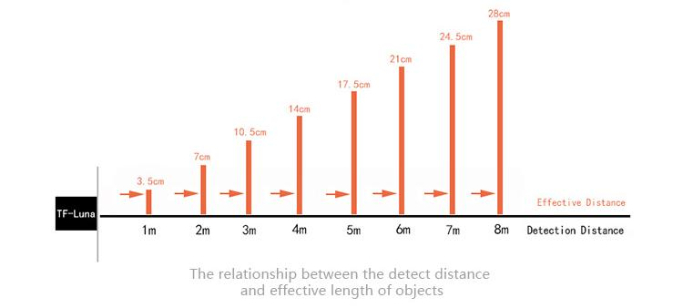

Figure 10 "TF-Luna sensor: detection distance and corresponding object size."

## Core components:

1. Jetson Nano board for processing
2. LiDAR for distance measurement and obstacle detection
3. Camera for road sign recognition
4. Radar for blind spot monitoring
5. Motor drivers and sensors for vehicle control

## Design Alternatives and Justification

Several alternatives were considered in the design phase, particularly concerning sensor types and processing units.

- **Processing Unit**: Alternatives included using Raspberry Pi, Arduino, or Jetson Nano. The **Jetson Nano** was selected due to its superior capability in handling machine learning tasks and image processing, which is essential for real-time road sign Recognition.

- **Sensors**: Various options for proximity sensing were explored, including **Ultrasonic Sensors** versus **LiDAR** for adaptive cruise control. **LiDAR** was selected for its higher accuracy and ability to provide detailed distance information for safe driving adjustments.

- **Blind Spot Detection**: Both **Radar** and **Camera-based** solutions were considered. Radar was chosen for its reliability in detecting nearby objects, even in low-visibility conditions.

These design decisions were made based on the constraints of processing power, accuracy, and real-time response requirements.

## Description of the Selected Design

The selected design integrates multiple subsystems working together to simulate ADAS functionalities. The **Jetson Nano** serves as the central processing unit, receiving data from various sensors such as the camera, LiDAR, and radar. The system processes this information to make real-time decisions, such as adjusting speed for adaptive cruise control or providing alerts for blind spot detection. The **Interactive Surface** (a touchscreen or projected interface) displays real-time feedback to the user, including alerts about detected road signs or surrounding vehicles.

## Block Diagram and Subsystem Functions

Below is an overview of the block diagram and the key subsystems:

- **Processing Unit (Jetson Nano)**: Handles real-time data processing, running machine learning algorithms for road sign detection and controlling the subsystems.

- **LiDAR Sensor**: Measures distances between the vehicle and obstacles, enabling Adaptive Cruise Control.

- **Radar Sensor**: Monitors blind spots and warns the driver when objects are detected.

- **Camera**: Captures images for Road Sign Recognition and lane tracking.

- **Motor Drivers**: Controls the speed and direction of the vehicle based on data from the sensors.

- **Interactive Surface**: Displays real-time feedback and allows the driver to interact with system settings.

## Expected cost

The project is designed with cost-efficiency in mind, selecting economical yet high-performing components. The estimated total cost is **35,000 EGP** including the Jetson Nano, LiDAR, radar sensors, camera, and motor drivers.

## Environmental Impact

The project has minimal environmental impact, as it focuses on energy-efficient components. By simulating ADAS on a small-scale vehicle, the energy consumption and waste generation were significantly lower than a full-scale prototype. Additionally, the implementation of such systems in real-world vehicles contributes to reduced fuel consumption and emissions by improving driving efficiency.

## Manufacturability

The design can be easily scaled for mass production, with standard components such as the Jetson Nano and LiDAR being widely available. The small-scale prototype can serve as a foundation for larger, real-world systems, with minimal adjustments needed for manufacturability.

## Ethics

Ethical considerations include the system’s reliance on accurate real-time data processing to ensure safety. Careful testing and validation are required to avoid any system failures that could result in accidents. Moreover, user privacy is a concern, especially with cameras and sensors that collect data, which must be handled responsibly.

## Social and Economic Impact

The project has significant social implications, as it demonstrates the potential to reduce traffic accidents and improve road safety, contributing to the well-being of society. Economically, ADAS can reduce the costs associated with accidents and vehicle repairs, as well as enhance vehicle efficiency, potentially leading to lower fuel consumption.

## Health and Safety

The ADAS functionalities directly improve health and safety by reducing driver fatigue, enhancing awareness of surroundings, and mitigating the risks of collisions. Features such as adaptive cruise control and blind spot detection play critical roles in preventing accidents, thus ensuring a safer driving environment.

## Sustainability

The project is designed with sustainability in mind, focusing on energy-efficient components and long-term use. ADAS in real-world applications can promote sustainability by improving fuel efficiency, reducing emissions, and supporting safer, more responsible driving behaviors, contributing to the longevity and environmental sustainability of transportation systems.

# References

1. **"Automotive Embedded Systems Handbook"** by Nicolas Navet and Francoise Simonot-Lion
2. Augustine, Stephen Tipa. *Design and Implementation of a Blind Spot Detection and Monitoring System for The Kayoola Buses*. Diss. 2022.‏
3. Waveshare. "TF-Luna LiDAR Range Sensor." Waveshare Wiki, n.d., [Online]. Available: <https://www.waveshare.com/wiki/TF-Luna_LiDAR_Range_Sensor> Accessed 12 Jan 2024.
4. P. Azevedo, "What is the best YOLO," 8 Jun 2022. [Online]. Available: https://medium.com/@pedroazevedo6/what-is-the-best-yolo-8526b53414af. Accessed 20 Jan 2024.
5. Bruno Siciliano, et al., *Springer Handbook of Robotics*. Second Edition, Springer Berlin Publishing, Heidelberg, 2016. 1627-1656.‏
6. j. pryslak, "medium," 23 April 2020. [Online]. Available: <https://medium.com/@jpriceless/visuals-depicting-the-relationship-between-ai-and-other-related-terms-8098520be8c4> . Accessed 4 Jan 2024.
7. Nvidia. "Jetson." Nvidia Developer, n.d., https://developer.nvidia.com/jetson. Accessed 11 Nov 2023.

**Project 2 : Autonomous Mobile Robot**

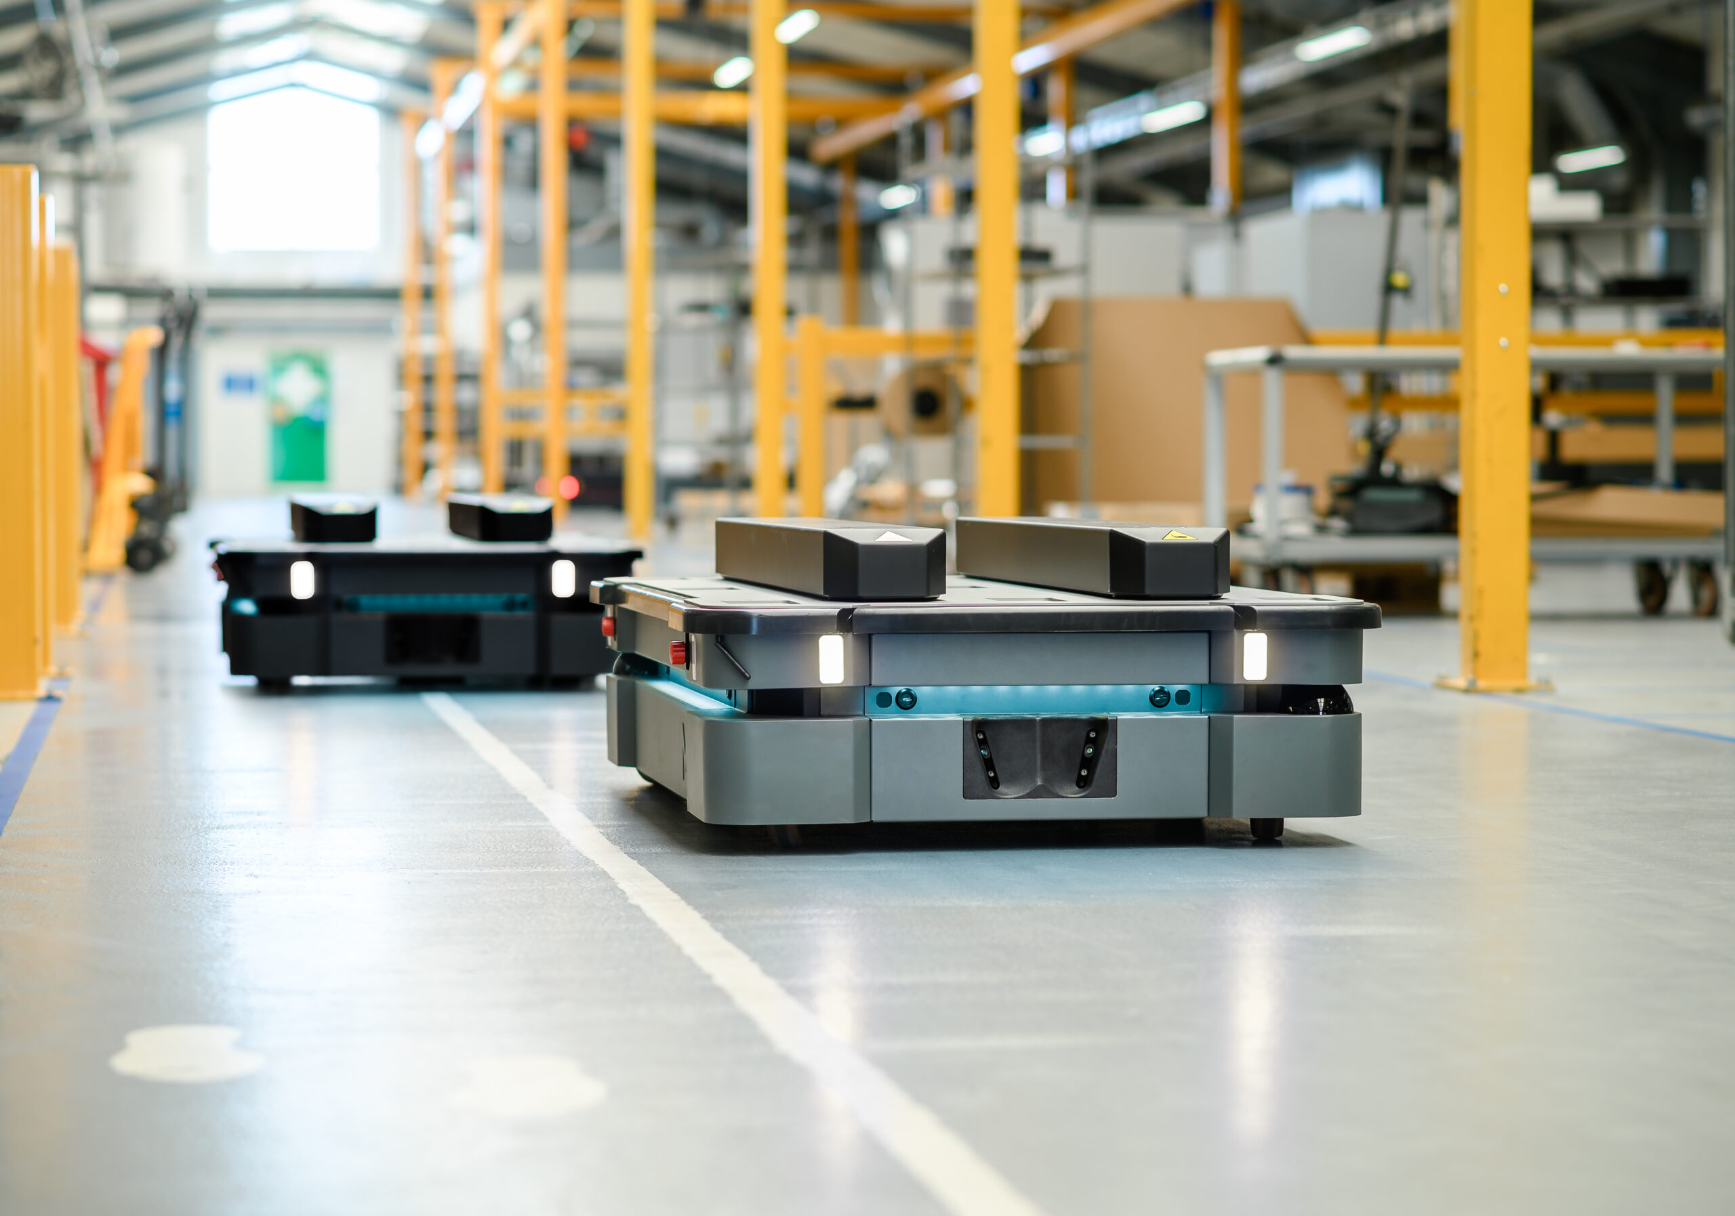

# ABSTRACT For Autonomous vehicles

Autonomous vehicles have been invented to increase the safety of transportation users. These vehicles can sense their environment and make decisions without any external aid to produce an optimal route to reach a destination. This type of system can bring a revolution in transportation for differently abled people and help blind people travel independently.

In our project, we will be working on autonomous vehicles that can use Simultaneous Localization and Mapping (SLAM) and Robot Operating System (ROS) in autonomous vehicles with mapping and path planning. Navigation2 stack autonomous vehicles can navigate via different path planning algorithms using the map Previously built, all of these were achieved using sensors such as lidar and Kinect cameras.

## Introduction and Literature review

We survey research on This self-driving technology mainly deals with the vehicles that can work and move themselves by sensing the movements and environment without any human presence. These self-driving vehicles are also known as autonomous vehicles. A human driver nor any human passenger is needed compulsorily to operate this vehicle. It totally works on the operations done through sensors, remote controlled operations, artificial intelligence. Thus, making it a product of mechatronics field. A Vehicle that has functionality of autonomous, it means it will aware by itself and has capability to choose by itself. For example, you say “drive me to work”, instead to follow your instruction it will be start to drive at another point, no it will not happen, an autonomous vehicle will follow the driver instructions and will reach the destination as driver want.

## Mechanical design Project Design

### Introduction:

Mechanical design is the process of designing components, parts, products, and systems of mechanical nature. The primary objective of mechanical design is to ensure that the final product or system is safe, reliable, efficient, and cost-effective. We will go to select the material and do calculations.

### Material:

Many different materials are used in the manufacture of autonomous vehicles body and the most used materials nowadays are steel, aluminum, stainless steel, and acrylic. We chose acrylic material for the car body

The Advantages of Acrylic:

• Easy to Fabricate and Shape

• light weight and ideal for precision machining

• Highly impact resistance

• Easy to Maintain

## A table with text on itDifference between Self-Driving Cars and Regular Cars:

## Advantages of Self-Driving Cars:

1. Reduced Costs: In 2021, the U.S. reported 42,915 vehicular fatalities, with 94% of crashes attributed to human error. Autonomous vehicles (AVs) have the potential to significantly reduce human error, which could lower crash rates by up to 90% and potentially save approximately $190 billion per year.

1. Increased Safety: Driver fatigue, inattention, or incorrect behavior are the causes of almost 99% of accidents. With AVs, human error is eliminated. These vehicles, equipped with advanced sensors, cameras, and AI, can make driving more efficient and reduce the accident rate. They also have faster reaction times, leading to shorter braking and starting times.

1. More Time and Comfort: Depending on the level of autonomy, drivers can relax, take breaks, or focus on other activities. In fully autonomous (level 5) vehicles, passengers can fully rely on the vehicle to take them to their destination without needing to drive.

1. Accessibility for Elderly and Disabled: Self-driving cars can offer a safe and timely journey for the elderly or visually impaired individuals who are otherwise unable to drive, helping them maintain independence and mobility.
2. Autonomous vehicle Levels of Autonomous **A diagram of a car driving process

   Description automatically generated with medium confidence**

## Autonomous Vehicle Technologies:

AVs use combinations of technologies and sensors to sense the roadway, other vehicles, and objects on and along the roadway.[2]

## Working of Automated Vehicle:

For an intelligent vehicle, the first step is to determine its current position in the world. This requires understanding local coordinates, road boundaries, and intersections, which is referred to as a local map. Two types of maps can be used: real-time maps or stored maps.

1. Real-time Mapping: In real-time map generation, various components such as RNDF (Route Network Definition File), GPS, cameras, lidar, and radar are employed.
2. Object Detection and Collision Avoidance: Short-range proximity radar and ultrasonic sensors are used to identify objects near the vehicle to prevent collisions.
3. Signal and Vehicle Tracking: Video cameras are used to track traffic signals, school lane signals, and other vehicles.
4. Distance Measurement and Road Identification: Lidar (Light Detection and Ranging) is utilized to measure distances, detect road edges, and identify lane markings.

## Development of Autonomous Vehicles:

Autonomous vehicle (AV) research began in the 1980s when universities started working on two types of AVs: one that relied on roadway infrastructure and one that did not. The U.S. Defense Advanced Research Projects Agency (DARPA) hosted “grand challenges” to test the performance of AVs on a 150-mile off-road course. Although no vehicles finished the 2004 Grand Challenge, five vehicles completed the course in 2005. In 2007, six teams successfully finished the third DARPA challenge, which involved navigating a 60-mile urban course while obeying traffic laws.

In 2015, the University of Michigan launched Mcity, the first dedicated testing facility for autonomous vehicles. Research at Mcity focuses on the safety, efficiency, accessibility, and commercial viability of AVs. Additionally, unmanned aircraft systems (UAS), or drones, are being deployed for commercial ventures like last-mile package delivery, medical supply transport, and critical infrastructure inspection.

**Project 3: Smart home System**

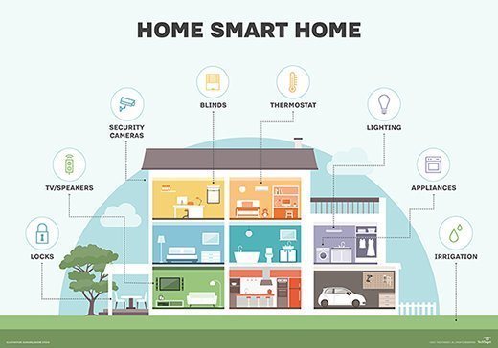

Contents

1 ABSTRACT 4

2 Chapter one: Introduction and Literature review 5

2.1 Introduction 5

2.2 Literature Review 6

3 Chapter 2: Project Design 8

3.1 Components and Circuit Design 8

3.1.1 Raspberry Pi 8

3.1.2 Smart Lighting System 8

3.1.3 Environmental Alert System 8

3.1.4 Water Level Monitoring System 9

3.1.5 Smart Door System (RFID/NFC) 9

3.1.6 Smart Curtain System 9

4 Conclusion 10

# ABSTRACT

The concept of smart homes has rapidly evolved with the integration of Internet of Things (IoT) devices, providing homeowners with enhanced control, convenience, and security. This project proposes a comprehensive smart home automation system utilizing IoT technologies to control various home appliances and provide real-time alerts for safety and comfort.

The system comprises five main features:

1-Smart Lighting System: This feature enables remote control of home lighting through the mobile mobile application. Users can turn lights on or off using their smartphones, offering convenience and energy efficiency by managing the lighting remotely.

2-Alert System (Gas Sensor and Environmental Monitoring): Safety is a crucial aspect of smart homes. This system uses a gas sensor to detect hazardous gas leaks and immediately sends an alert to the user through the mobile app. Additionally, a DHT11 sensor monitors temperature and humidity levels, providing real-time environmental data to enhance comfort and safety.

3-Water Level Monitoring for Tank: To ensure water supply management, the system includes a water level alert mechanism for the household tank. When the water reaches critical levels, users receive notifications, allowing them to take action to refill or conserve water.

4-Smart Door Access (RFID/NFC Module): Security is enhanced through a smart door system that utilizes RFID or NFC technology. Only authorized users with registered RFID tags or NFC devices can unlock the door, providing a secure and automated entry system.

5-Smart Curtain Control: Through the mobile app, users can remotely open or close curtains, adding a layer of comfort and energy efficiency by controlling sunlight exposure inside the home.

# Chapter one: Introduction and Literature review

## Introduction

The concept of smart homes has transformed modern living by incorporating technology and automation into everyday household activities. Leveraging the Internet of Things (IoT), smart homes create an interconnected network of devices and systems, allowing for remote control and monitoring of various functions such as lighting, security, environmental management, and access control. The result is a more convenient, efficient, and secure living environment.

This project proposes a smart home system implemented on a Raspberry Pi, integrating multiple smart subsystems: lighting control, environmental alert systems, water level monitoring, door access management, and automated curtains. All these systems are centrally controlled using the mobile IoT platform, which provides a unified interface for managing the various components.

The smart light system allows remote control of household lighting via the mobile app, providing the convenience of managing lighting from anywhere. The environmental alert system, which monitors conditions such as gas leaks, temperature, and humidity through gas and DHT11 sensors, sends real-time notifications when abnormal conditions are detected. The water level monitoring system uses an ultrasonic sensor to ensure that household water storage is efficiently managed, notifying users when water levels are too high or too low. For enhanced home security, the smart door system uses RFID or NFC technology for secure and contactless access control. Lastly, the smart curtain system automates the opening and closing of curtains, helping regulate natural light and potentially improving energy efficiency.

By using mobile as the central platform, users can control all these smart home systems from a single interface on their mobile devices. The integration of these components into a unified system demonstrates the potential for smart homes to provide a seamless and intelligent living experience.

## Literature Review

The development of smart home technologies has been driven by advancements in IoT devices, wireless communication, and automation systems. Smart lighting has been a popular area of research, with studies such as those by Suryady et al. (2016) demonstrating how automated lighting systems that respond to user presence or environmental conditions can significantly enhance energy efficiency. mobile has emerged as a favored IoT platform for integrating remote control features into such systems, offering users real-time control via smartphones, as highlighted by Patel et al. (2018).

In the area of environmental monitoring, gas sensors and DHT11 temperature and humidity sensors are commonly utilized to detect hazardous situations in smart homes. According to Kumar et al. (2017), incorporating these sensors into home automation systems greatly improves household safety by allowing early detection of gas leaks and ensuring indoor air quality. Such systems can provide real-time alerts, enabling users to respond promptly to potential hazards.

Water level monitoring is another critical aspect of smart home systems. Gupta and Purohit (2020) demonstrate the benefits of ultrasonic sensor-based systems, which, when integrated with IoT platforms, allow users to monitor water levels in real time. This not only helps prevent overflow but also optimizes water consumption, a vital feature in regions experiencing water shortages.

Smart access control systems, utilizing RFID or NFC technology, are gaining popularity due to their enhanced security and convenience. Research by Le et al. (2019) highlights how these systems, when combined with IoT platforms, allow homeowners to control door access via smartphones. This adds flexibility and reduces the risks associated with traditional key-based entry.

While still a relatively new area, the automation of curtains is another promising field in smart home technology. Pradeep and Sivabalan (2018) show that automated curtains can contribute to energy savings by controlling natural light and heat inflow, reducing the need for artificial lighting and air conditioning. The combination of comfort and energy efficiency makes this system an attractive addition to smart homes.

This project extends these individual smart home components by integrating them into a single system controlled by a Raspberry Pi and the ,mobile platform. The use of Raspberry Pi, with its more powerful processing capabilities compared to NodeMCU, provides greater flexibility in handling more complex tasks and adding future expansions to the system. Additionally, mobile app simplifies user interaction by offering real-time control and feedback through a single interface. This comprehensive approach demonstrates the potential for creating highly functional and user-friendly smart home systems.

# Chapter 2: Project Design

## Components and Circuit Design

### Smart Lighting System

The smart lighting subsystem consists of:

- **Relay Module**: A relay controls the light, switching it on or off based on commands from the mobile app.

- **Light Bulb**: Connected to the relay, the light bulb is powered or unpowered by the relay's state.

- **mobile Interface**: Users control the light with a toggle button on the mobile app.

**Circuit Design:** The relay module is connected to a GPIO pin on the Raspberry Pi. The light bulb's power supply passes through the relay. When the user sends a control signal from the mobile app, it triggers the relay, toggling the light on or off.

### Environmental Alert System

This subsystem monitors for gas leaks and environmental conditions using:

- *MQ-2 Gas Sensor*: Detects harmful gases like methane and propane.

- *DHT11 Sensor*: Measures temperature and humidity.

- *mobile Interface*: Displays real-time sensor data and sends alerts when thresholds are exceeded.

**Circuit Design:** The MQ-2 gas sensor and DHT11 sensor are connected to different GPIO pins on the Raspberry Pi. The sensor data is processed and sent to the Mobile app, where it is displayed and alert thresholds can be set.

### Water Level Monitoring System

The water level in a tank is measured using an *ultrasonic sensor* (HC-SR04), which calculates the distance between the sensor and the water surface. When the water level reaches critical points, alerts are sent via the Mobile app.

- **Ultrasonic Sensor (HC-SR04):** Measures the distance from the sensor to the water surface.

- **Mobile Interface:** Notifies the user when water levels are too low or too high.

**Circuit Design:** The ultrasonic sensor is connected to GPIO pins of the Raspberry Pi. It measures the time taken for sound waves to reflect off the water surface, calculates the distance, and sends the data to the Mobile app for user alerts.

### Smart Door System (RFID/NFC)

The smart door system uses an *RFID* or *NFC module* for access control:

- **RFID/NFC Module:** Reads RFID tags or NFC-enabled devices to unlock the door.

- **Servo Motor:** Controls the physical locking mechanism.

- **Mobile Interface:** Allows users to monitor or remotely unlock the door.

**Circuit Design:** The RFID/NFC module connects to the Raspberry Pi’s GPIO pins. When an authorized RFID tag or NFC device is detected, the Raspberry Pi triggers the servo motor to unlock the door.

### Smart Curtain System

The smart curtain system uses a *servo motor* to open or close the curtains:

- **Servo Motor:** Moves the curtain based on user commands.

- **Mobile Interface:** Provides users with a remote option to adjust the curtain position.

**5. System Operation and Workflow**

**1. Power Initialization:** The Raspberry Pi is powered, initializing the sensors, actuators, and relays.

**2.Sensor Input:** Environmental sensors (e.g., gas, temperature, humidity) continuously monitor their parameters and send data to the Raspberry Pi.

**3. User Interaction:** Users view real-time data, control lights, unlock the door, or adjust curtains via the Mobile app.

**4. Automation and Alerts:** If a sensor detects an abnormal condition (e.g., gas leak or low water level), the system sends an alert through the Mobile app.

**5. Manual Control:** The user can manually trigger actions, such as turning on the lights or unlocking the door, from the mobile interface.

# Conclusion

This chapter detailed the design and implementation of a smart home control system using Raspberry Pi and IoT technologies. The system includes smart lighting, environmental monitoring, water level detection, access control, and automated curtain subsystems. All components are managed through the Raspberry Pi and mobile platform for remote control and real-time monitoring. This design's scalability and flexibility make it adaptable for future expansions, offering a versatile solution for modern smart homes.